**E-Commerce Website Description**

What is e-commerce

* Commonly known as Electronic Marketing
* “It consist of buying and selling goods and services over an electronic system such as the internet and other computer network”

About over system

* Our System is an e-Commerce website where people can buy product online.
* Admin Monitors the activity of the users and checks the transaction.

**E-Commerce Shopping Process Diagram**

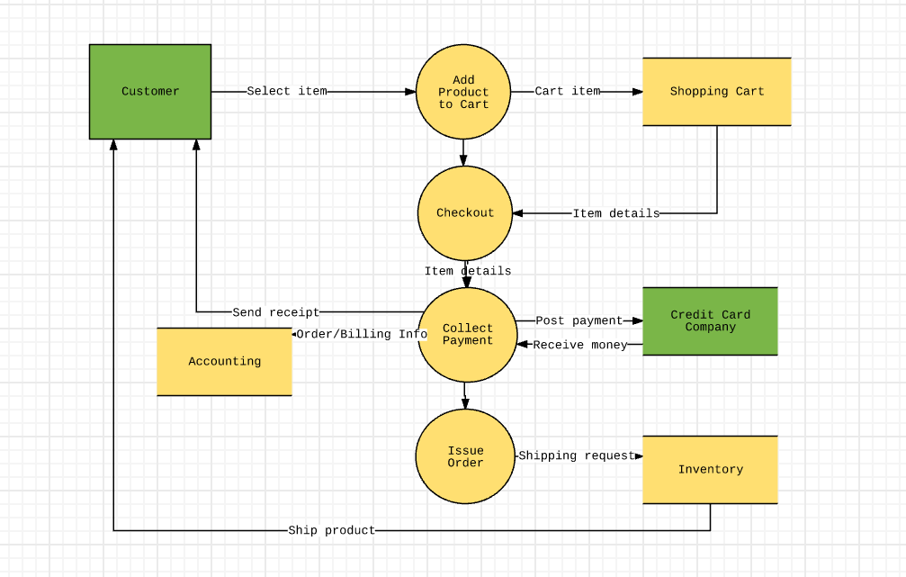

**Features**

* Menu
* Category
  + Shop
  + Men
  + Women
  + Kids
* Shopping Cart
* Login & Signup

**Languages**

* Html 5
* CSS 3
* React Js

**Tools**

* Vs Code
* MongoDB

**Home Page**

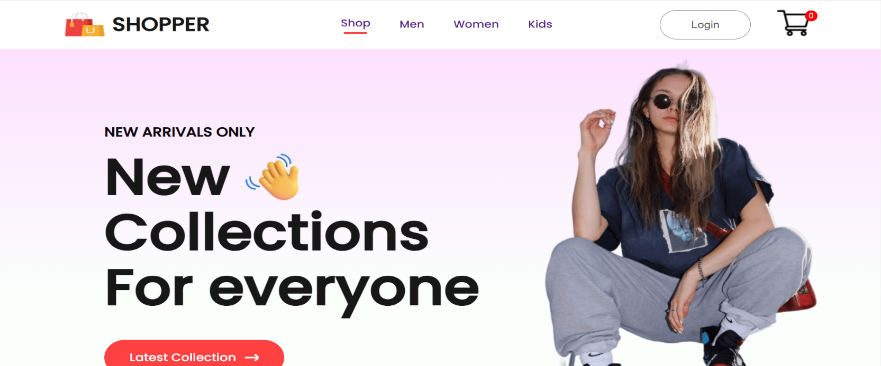

A home page (or homepage) is the main web page of a website. The term may also refer to the start page shown in a web browser when the application first opens. Usually, the home page is located at the root of the website's domain or subdomain.

* Category
  + Shop – All Over Description
  + Men – Only for Men Clothes
  + Women – Only for Women Clothes
  + Kids - Only for Kids Clothes
* Login & Signup
* Shopping Cart

**Men page**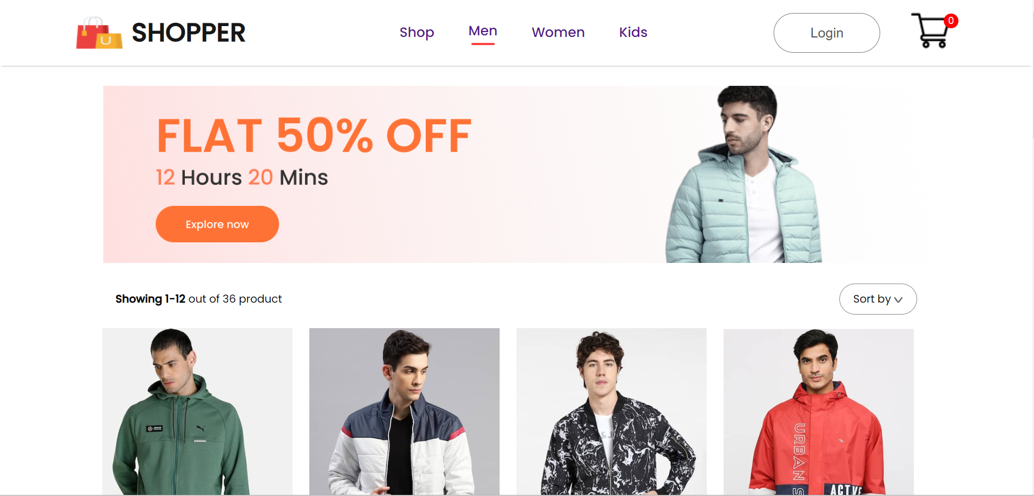

**Women page**

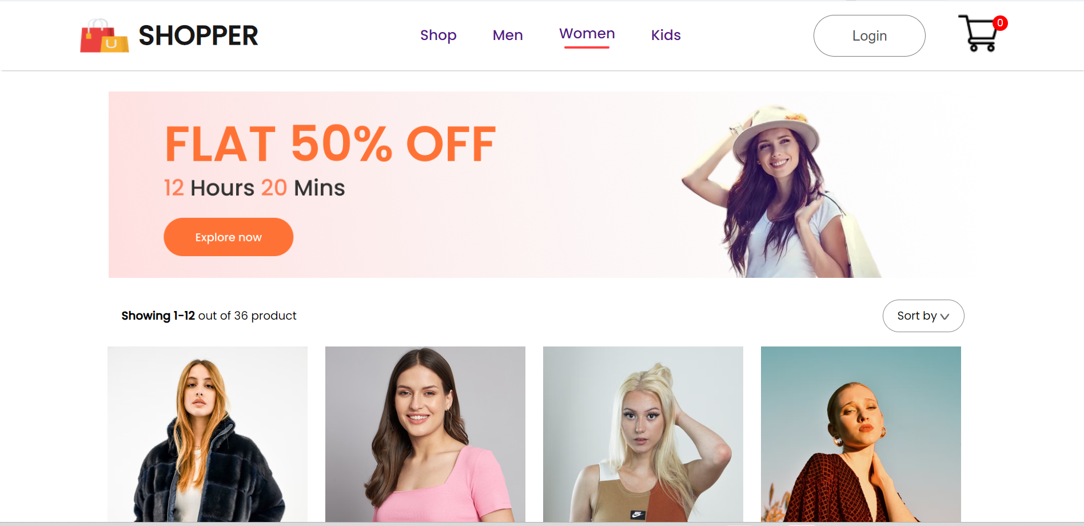

**Kids page**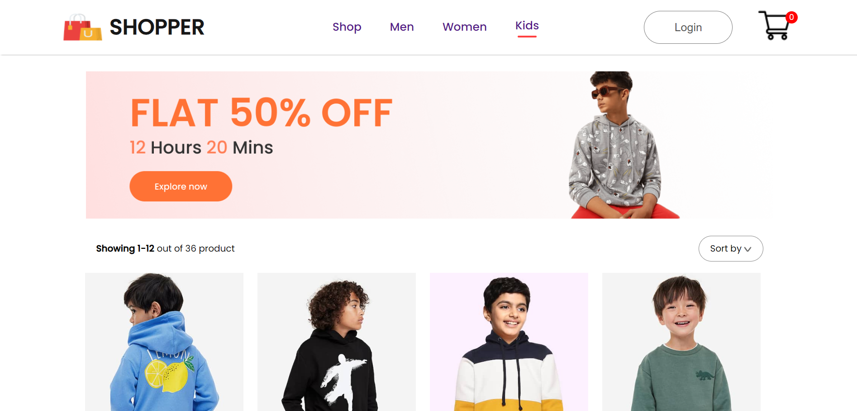

**Product page**

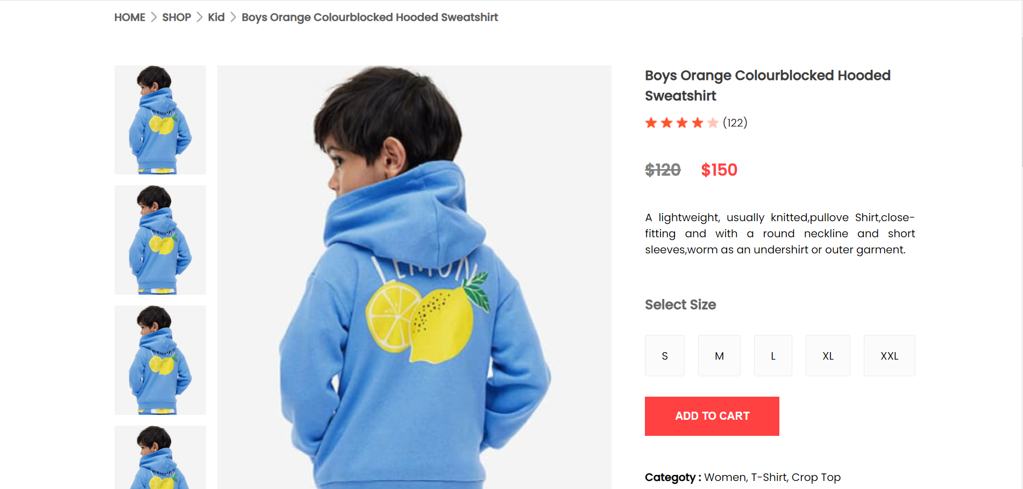

Click to the “ADD TO CART”

**Cart page**

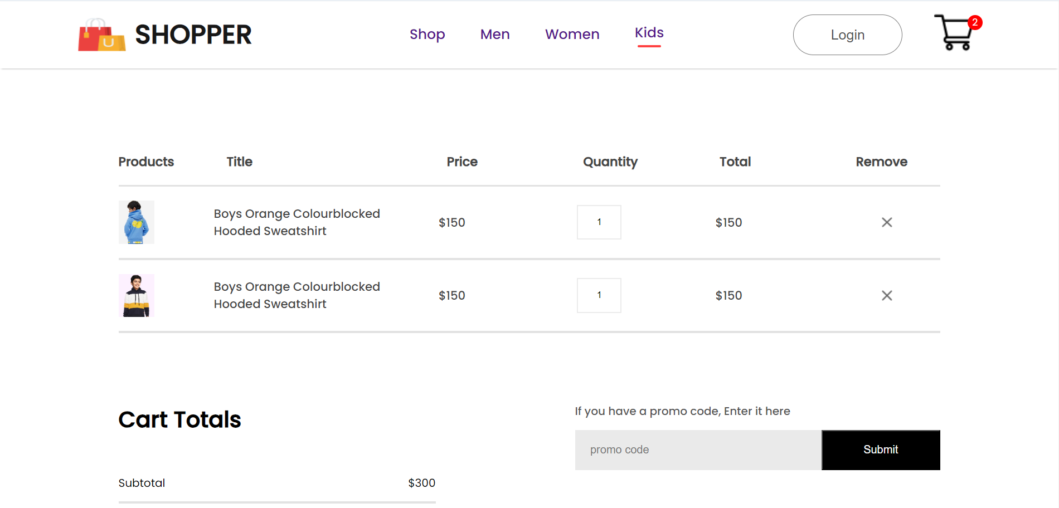

**Login page**

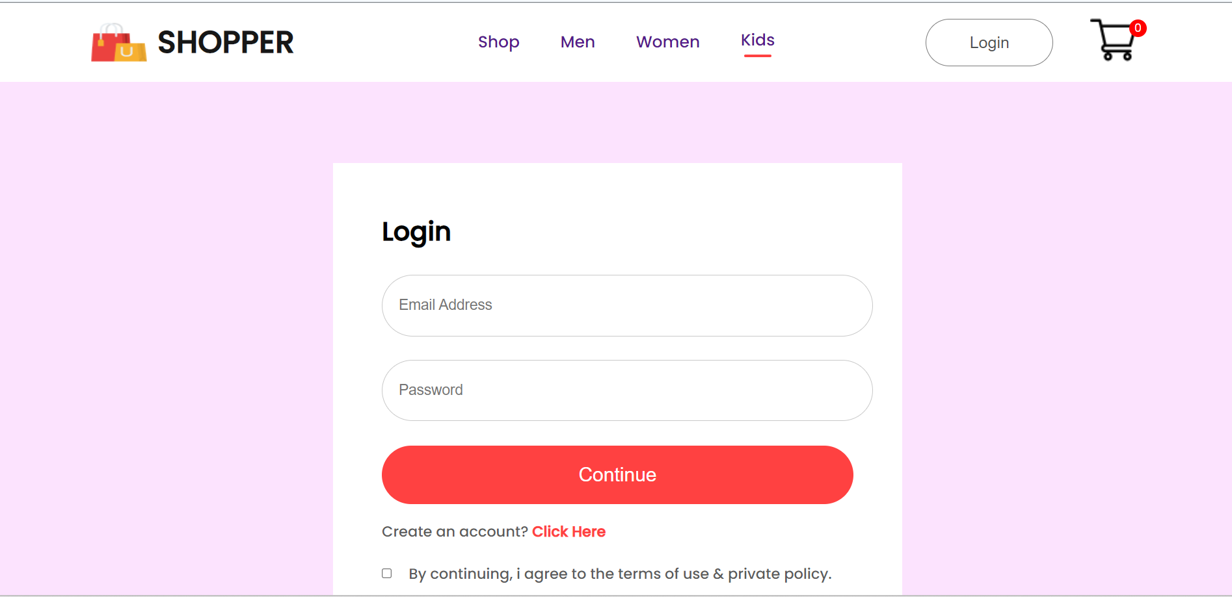

**Signup page**

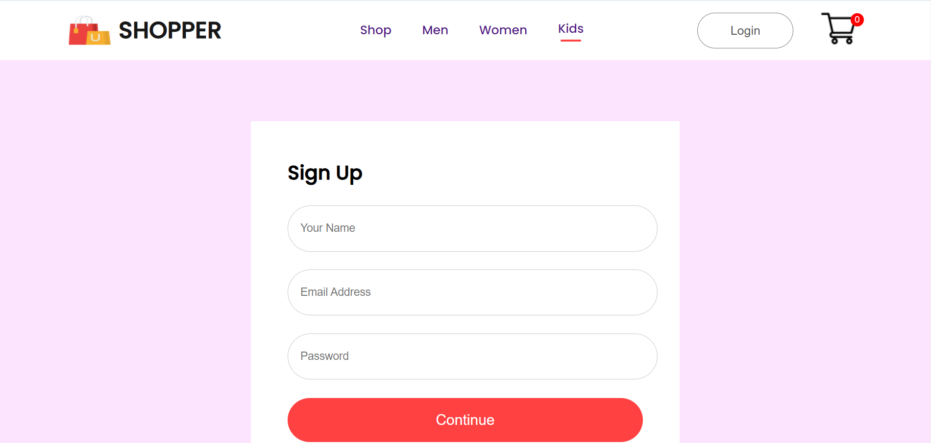

**Admin page**

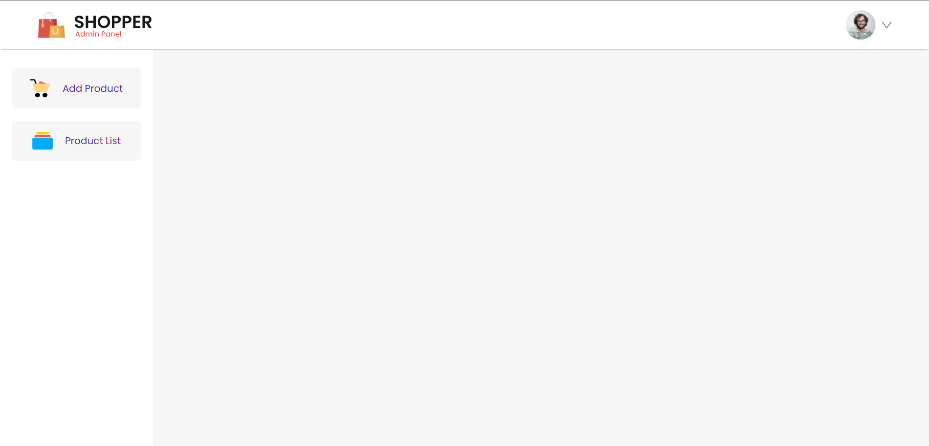

* Two Category
* Add Product – New Product add in website
* Product List – All product list

**Product Insert page**

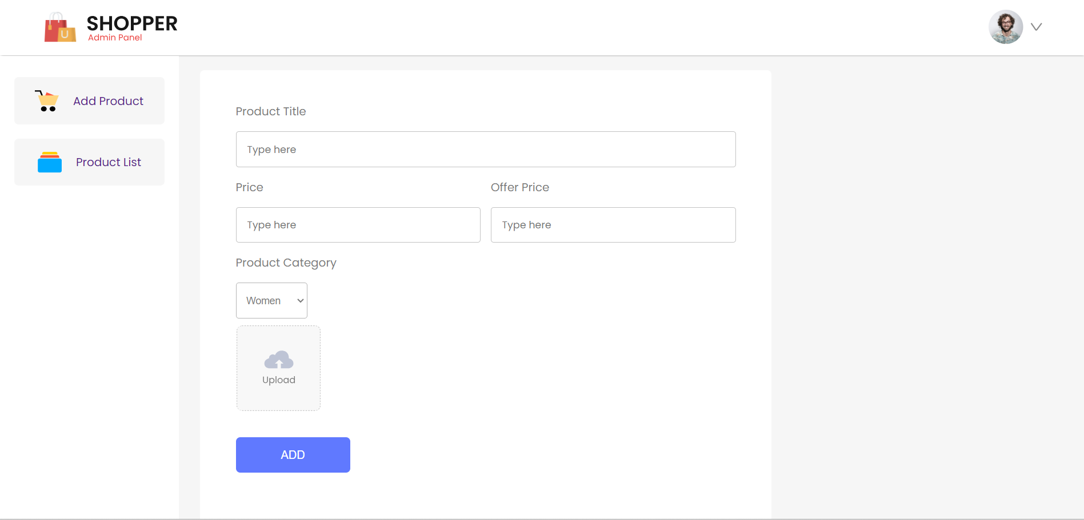

Click to the “ADD Button”

**Product List**

